**Algebra IA** Name _________________________________ 1.5/1.6 Worksheet Date ___________________ Hour ______

Represent Functions as Rules and Tables

**Tell whether the pairing is a function.**

1.

|  |  |
| --- | --- |
| **Input** | **Output** |
| 1 | 15 |
| 3 | 20 |
| 5 | 15 |
| 7 | 20 |

2.

|  |  |
| --- | --- |
| **Input** | **Output** |
| 5 | 5 |
| 6 | 5 |
| 7 | 5 |
| 8 | 5 |

3.

|  |  |
| --- | --- |
| Input | Output |
| 6  12  12  18  4  3  2  1 | |

**Write a rule for the function.**

4.

|  |  |  |  |  |
| --- | --- | --- | --- | --- |
| **Input, *x*** | 2 | 3 | 4 | 5 |
| **Output, *y*** | 14 | 21 | 28 | 35 |

5.

|  |  |  |  |  |
| --- | --- | --- | --- | --- |
| **Input, *x*** | 10 | 20 | 30 | 40 |
| **Output, *y*** | 2 | 4 | 6 | 8 |

1. **Shoe Sizes** The table shows men’s shoe sizes in the United States and Australia. Write a rule for the Australian size as a function of the United States’ size.

|  |  |  |  |  |  |  |
| --- | --- | --- | --- | --- | --- | --- |
| **U.S. size** | 5 | 6 | 7 | 8 | 9 | 10 |
| **Australian size** | 3 | 4 | 5 | 6 | 7 | 8 |

**Graph the ordered pairs.**

7. (3,4), (4,7), (5,10), (6,13), (7,16)

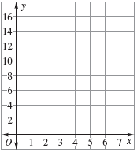

8. (2,5),(6,7),(4,6),(12,10),(10,9)

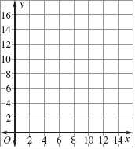

**Complete the input-output table for the function. Identify the domain and range.**

9. *y* = 3*x* + 2

|  |  |  |  |  |
| --- | --- | --- | --- | --- |
| ***X*** | 0 | 1 | 2 | 3 |
| ***Y*** |  |  |  |  |

10. *y* = 4*x* – 1

|  |  |  |  |  |
| --- | --- | --- | --- | --- |
| **X** | 1 | 2 | 3 | 4 |
| **Y** |  |  |  |  |

**Make a table and graph the function**s.

11.  *y* = 15/x

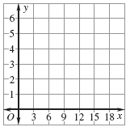Domain: 15, 12, 9, 6, 3

12. y = 4*x* – 3

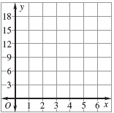 Domain: 1,2,3,4,5

1. 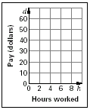**Hourly Pay** The table shows the pay *d* (in dollars) as a function of the number of hours worked *h*. Graph the function.

|  |  |  |  |  |  |
| --- | --- | --- | --- | --- | --- |
| **Hours worked, *h*** | 1 | 2 | 3 | 5 | 8 |
| **Pay (dollars), *d*** | 6.75 | 13.50 | 20.25 | 33.75 | 54 |